Comparing four predictors in estimating survival quantile using Monte Carlo samples

Gang Han, 02/08/2011

Eight predictors:
% 1, Kaplan-Meier binomial distribution
% 2, Kaplan-Meier averaging over length 30
% 3, Exponential all the way
% 4, Exponential up to a point
% 5, Kaplan-Meier averaging over length 10
% 6, Gamma
% 7, Weibull
% 8, Lognormal

Set up of the problem:
* Estimating the quantile at 100 when the true distribution is exp(120). The true quantile is exp(-100/120) = 0.4346.

Generate data from Exponential (120) with a sample size. Generate 5000 such samples, and estimate the quantile. No censoring.
- predictor 2 is the average over the window of 30
- predictor 4 is the exponential distribution up to time 150. If the generated random number is larger than 150, then we treat the time as censoring.

1, Sample Size = 15.
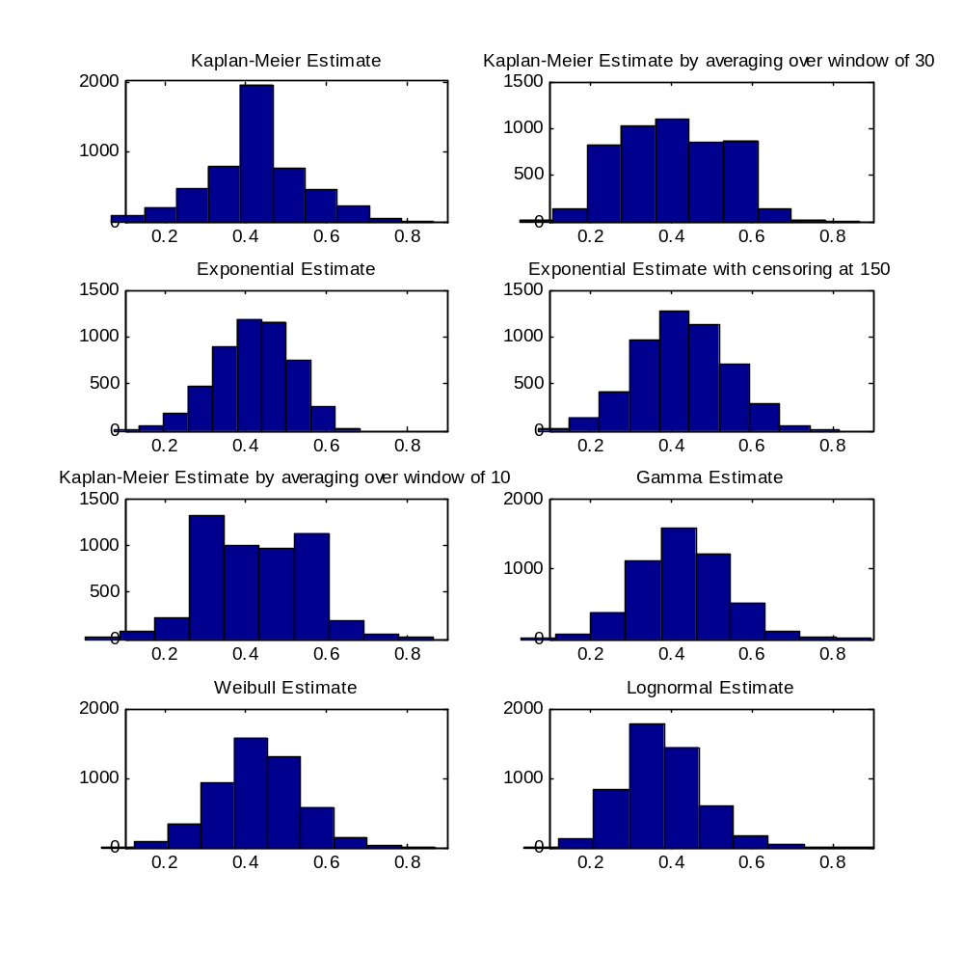
Figure 1. Plots the estimated quantile from the 8 estimates

Table 1 lists the root mean squared prediction error (RMSPE), sample variance, and bias of the four predictors when the sample size is 15.
 | Sample Variance | Bias | RMSPE
1, Kaplan-Meier | 0.0162 | -0.0027 | 0.1275
2, Kaplan-Meier with window of 30 | 0.0158 | -0.0339 | 0.1300
3, Exponential | 0.0087 | -0.0155 | 0.0946
4, Exponential with censor at 150 | 0.0120 | -0.0062 | 0.1098
5, Kaplan-Meier with window of 10 | 0.0164 | -0.0092 | 0.1284
6, Gamma | 0.0115 | -0.0058 | 0.1072
7, Weibull | 0.0110 | -0.0031 | 0.1051
8, Lognormal | 0.0096 | -0.0554 | 0.1127

